**State institution "Soligorsky regional territorial center of social services of the population" invites to cooperation and co-financing in the framework of a humanitarian project**

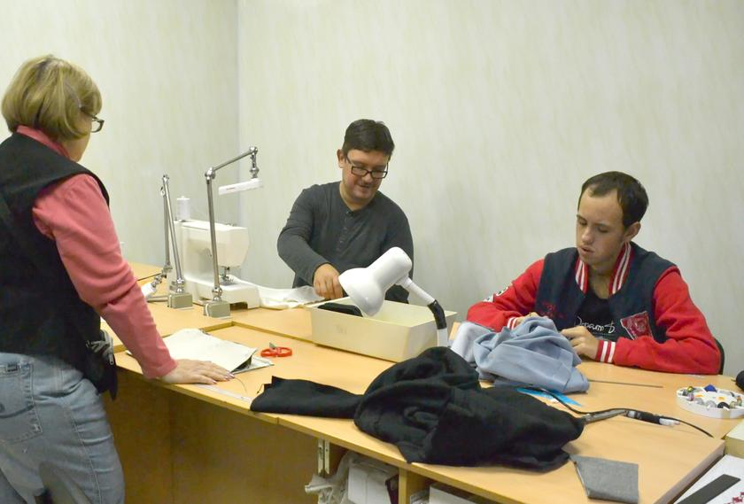**"From heart to heart»**

|  |
| --- |
| **1. Project name:** "From heart to heart» |
| **2. Term of realization**: 1 year |
| **3. The applicant, the proposed project:** GU "Soligorsky regional territorial center of social services of the population » |
| 4. Justification of the project: 60 disabled and elderly citizens in need of constant outside care are in nursing beds in Krasnoslobodskaya city and Dolgovskaya district hospitals of the Soligorsky district. On average, 30 elderly citizens are accommodated in nursing beds per year. In these social institutions there is a problem of shortage of bed linen, towels, napkins.  On the basis of the State Institution "Soligorsky District Territorial Center for Social Services of the population" there is a department of social rehabilitation, habilitation of disabled people, where 43 people, disabled people of groups 1 and 2 are on day care. In the process of visiting the department, these people are engaged in various circles and clubs of interest, in social rehabilitation workshops. Many of them are trained in elementary labor skills of making souvenirs, sewing skills of simple products (towels, napkins, bedding). Due to disability, ward wards are unable to work in the main labor market, but they, like other people, want to feel their importance and relevance in society, because they have a certain potential to help other people.  Within the framework of this project, the socialization of 6 disabled people of 2 groups is provided, through the provision of assistance to 60 disabled and elderly people in nursing beds - the manufacture (sewing) of bedding (towels, napkins, bedding). To achieve the goals of this project, it is necessary to equip a sewing workshop, purchase the necessary consumables.  The manufactured garments will be transferred for use by disabled and elderly people who are in nursing beds in Krasnoslobodskaya city and Dolgovskaya district hospitals. Disabled people participating in this project will be able to work out and improve their sewing skills and use them in their further independent life. And the realization that they are able to benefit other people will help to increase their personal self-esteem and a sense of satisfaction with the results of their work. After the end of the project, the equipment of the sewing workshop remains on the balance sheet of the State Institution "Soligorsky District Territorial Center for Social Services of the Population" for the further work of disabled people in the rehabilitation and labor workshop. |
| **5. The goal of the project:** employment and socialization of young disabled people (tailoring of basic necessities) by providing assistance to elderly people who are in nursing beds in Krasnoslobodskaya city and Dolgovskaya district hospitals of the Soligorsky district. |
| **6. Tasks:** creating conditions for organizing the process of employment and socialization of young disabled people in a sewing workshop. |
| **7. Project target group:**  - young disabled people attending the department of social rehabilitation, habilitation of disabled people – 6 people;  - - disabled and elderly people who are on nursing beds in Krasnoslobodskaya city and Volkovskaya district hospitals of Soligorsky district – 60 people. |
| **8. Brief description of licensing activities within the project:**  Sewing workshop;  Purchase of necessary equipment and supplies;  Performing work on tailoring of basic necessities: bed linen, towels, handkerchiefs, headscarves;  Gear is made of garments on the bed and nursing care.  The project is planned accessories: sewing machine (4 PCs), overlock machine (1 PC), Ironing Board (2 PCs), iron (2 PCs), vacuum cleaner (1 PC.), kettle (1 PC.), rack (2 PCs), Cabinet (2 PCs.), cutting table (1 PCs.), chairs (6 PCs), mirror (1 PCs), light bulb (5 PCs.), extension (5 PCs.), rubber mats (5 pieces), scissors (5 PCs), ruler (5 PCs), the tape (4 PCs), thread, needles, machine oil, cloth. |
| 9. Total funding: € 6,500 |
| Source of funding Amount of funding |
| Donor funds € 6500 |
| 10. **Project location:** 8 Kozlov str., Soligorsk, Minsk region |
| 11. **Contact person:** Veronika V. Karpovich, Director, phone 8-017-4-234263, e-mail: tsoid@yandex.ru |

**We will be happy to cooperate!**