**Humanitarian project "Polygraphic workshop" for people with disabilities**

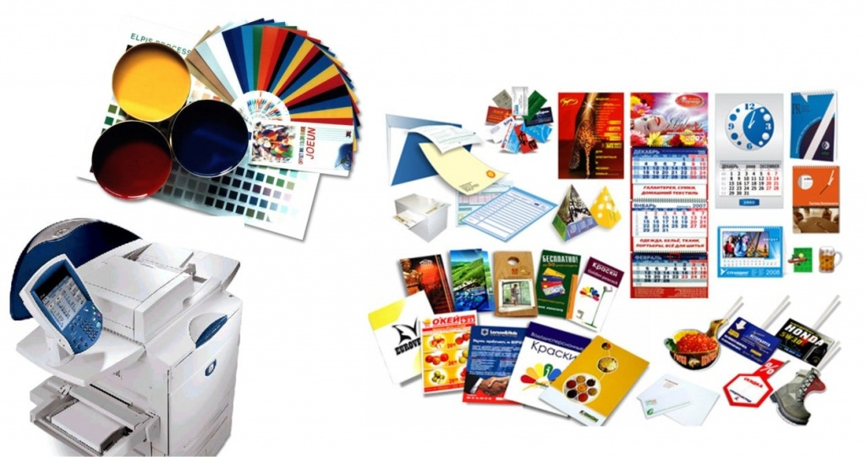

|  |  |  |
| --- | --- | --- |
|  | **Project name** | Humanitarian project "Polygraphic workshop" for people with disabilities |
|  | **Name of the organization** | Narovlyansky Territorial Center for Social Services of the Population |
|  | **The physical and legal address of the organization** | Legal address: 247802, Gomel region, Narovlya, Komsomolskaya str., 19. |
|  | **Head of the organization** | Vishnevskaya Galina Nikolaevna 8 02355 44507 narovlatcson@mintrud.by |
|  | **Required amount** | 10 000 USD |
|  | **Cofinancing** | 0 USD |
|  | **Project duration** | long-term |
|  | **The purpose of the project** | Creating conditions for people with disabilities to acquire professional skills in the field of printing, socialization of people with disabilities |
|  | **Project objectives** | 1. To equip a printing workshop in the premises of the Department of social rehabilitation and habilitation of the disabled;  2. To raise the level of knowledge of people with disabilities about modern technologies;  3. To familiarize people with disabilities with the practical activities of manufacturing printing products (taking into account their physical and mental abilities);  4. To teach the skills of working on printing equipment to the project participants;  5. Create conditions for the realization and development of personal, creative and labor potential;  6. To assist in the restoration, development (formation) of available labor and social skills;  7. Support for the independence and social activity of people with disabilities;  8. Souvenir production |
|  | **Detailed description of the project activities in accordance with the tasks set** | 1. Purchase and installation of printing equipment: personal computer (monitor, system unit, keyboard, mouse, speakers, uninterruptible power supply), multifunction thermal press, sublimation printer, color printer;  2. Purchase of consumables for the manufacture of printing products: paper of various densities for office equipment, photo paper, thermal scotch, thermal transfer paper, ink for sublimation printing, ink cartridges for a color printer, metal springs, plastic (for pamphletting), film for lancing, T-shirts, baseball caps, plates, mugs for printing;  3. Furnishing of the workshop room with furniture: a worktable, a cabinet for storing consumables, finished products;  4. To train 10-12 disabled people in groups 1 and 2 in the manufacture of printing products for making souvenirs. (the number of people was selected from the number of visitors to the Department of social rehabilitation and habilitation of the disabled);  5. Production and sale of competitive souvenir products at exhibitions and fairs in the city. Equipment and training make it possible to produce better quality souvenirs, which will increase the competitiveness of products and sales. This will increase the employment of people with disabilities and increase income from sales of products. The income will allow the purchase of new materials, increasing the variety of products, which stimulates and supports the interest in work among those employed in the workshop. This creates in people with disabilities a sense of their own usefulness in society, personal importance, and self-realization;  6. Posting information about the project in the media. |
|  | **Justification of the project** | People with disabilities, as the most vulnerable part of the population, need support and the creation of special conditions of the social environment, which are designed to help independent activity, the realization of their rights to education, work and a full life. The Department of social rehabilitation and habilitation of the disabled operates a rehabilitation and labor workshop "Polygraphy". The workshop's equipment (laminator, pamphlet maker, cutter) is currently insufficient for training and independent use by people with disabilities in the manufacture of printing souvenirs. Special equipment will make it possible to produce better products, which will increase competitiveness and sales. This will increase the employment of people with disabilities and increase income from sales of products. The income will allow the purchase of new materials, increasing the variety of products, which stimulates and supports the interest in work among those employed in the workshop. This creates a sense of well-being for people with disabilities |
|  | **Post-project activities** | The printing workshop will continue to operate. Purchase of materials for work at the expense of funds from the income received from the sale of souvenirs |
|  | **Project budget** | 10 000 USD |
|  | **Printing workshop equipment** | * personal computer (laptop); * мultifunctional 6-in-1 thermal press for sublimation; * color printer for freeze-dried ink; * freeze-dried ink; * sublimation printing paper; * thermoscatch; * supplies (cups, plates, T-shirts, caps, shoppers, etc.); * equipment table (workplace); * a cabinet for storing consumables and finished products |