**Institution "Narovlya Territorial Center for Social Services of the Population"**

**The humanitarian project “Massage – the path to health”**

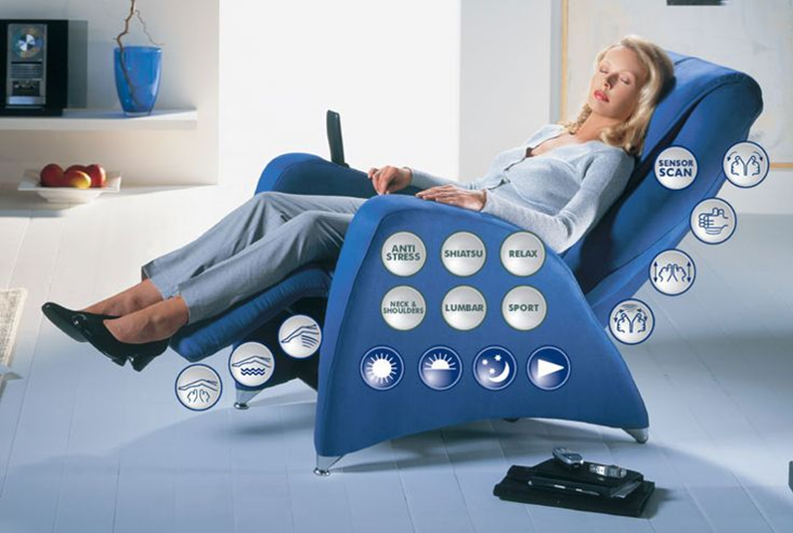

The department of social rehabilitation and habilitation of disabled people is independently attended by people with disabilities of the first and second groups. The work of the department's specialists is aimed at assisting people with disabilities in restoring skills for self-service that have been impaired or lost due to illness, preparing people with disabilities for an independent life; the development and maintenance of their skills of behavior, self-control, interpersonal communication, abilities and interests in work, the formation of accessible work skills; meeting the needs of people with disabilities and their family members in communication; organization of leisure for disabled people by creating hobby groups for them, clubs, rehabilitation and labor workshops, holding cultural events. According to the individual rehabilitation program, habilitation of a disabled person, the specialists of the department take into account all the needs of the potential recipient of services and the characteristics of his living conditions, and also assess the possibility of his recovery after an illness or injury. Massage chairs are made taking into account the recommendations of doctors, and this is one of the reasons for their popularity throughout the world. During the rehabilitation period, a massage chair is also a good alternative or addition to sessions with a massage therapist. Massage using a massage chair is a very popular procedure among any age. It gives a person a boost of energy, relieves fatigue and pain along the entire spinal column, relieves swelling and normalizes blood pressure. With regular use of a massage chair, fatigue and muscle tension are relieved, resistance to stress increases, the body is cleansed of toxins, blood flow is normalized and lymph circulation is restored. Just 30 minutes a day and you are always in great shape. Effectiveness of massage: - the functions of tapping, patting and kneading in a massage chair perfectly relieve excessive muscle tension, improve blood movement, and promote the supply of oxygen to tissues; - with regular procedures, after a few weeks you begin to notice that the migraine has passed, sleep has been restored, the lumbago in the lower back has stopped, the cracking of joints has stopped, memory has normalized, and the aching bones have disappeared. Massage chairs are equipped with built-in massage rollers that provide massage to the neck, lower back, back, hips, affecting acupuncture points, improving blood circulation and metabolism in body cells. The rubbing massage technique implemented in the chairs allows you to get rid of tension in the muscles of the body. Most massage chairs work harder than a human, performing massage techniques such as tapping, patting, and rubbing. A massage chair can be used as an aid in the treatment and prevention of osteochondrosis, sprains, and also to stimulate blood circulation.

|  |  |
| --- | --- |
| 1. Project name:  “Massage – the path to health” | |
| 2. Project implementation period: long-term | |
| 3. Organization - applicant proposing the project: Institution "Narovlya Territorial Center for Social Services of the Population" | |
| 4. Objectives of the project: preservation and strengthening of physical and mental health,  introduction to a healthy lifestyle through massage | |
| 5. Tasks planned for implementation within the framework of the project:  - removal of fatigue;  - activation of the internal processes of the body;  - improving blood circulation in people with disabilities. | |
| 6. Target group: disabled people attending the department of social rehabilitation, habilitation of the disabled | |
| 7. Brief description of the project:  - purchase of a massage chair;  - conducting massage courses to improve the well-being of people with disabilities. | |
| 8. Total funding (in US dollars):  5000 $ | |
| Source of financing | Amount of funding  (in US dollars) |
| Donor funds | 5000 $ |
| Co-financing | 0 $ |
| 9. Project implementation location: Narovlya, st. Komsomolskaya, 19, Gomel region, Republic of Belarus  Institution "Narovlya Territorial Center for Social Services of the Population" | |
| 10 The contact person:  Vishnevskaya Galina Nikolaevna, director of the institution “Narovlya Territorial Center for Social Services of the Population”, tel. work 8 02355- 44507;  mob. +37533 6530400, [narovlatcson@post.gomel.by](mailto:narovlatcson@post.gomel.by) | |

**We look forward to cooperation!**